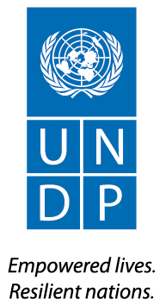

Public Administration Reform Program
  - OUTPUT BOARD REPORT

INTRODUCTION
Under UNDP’s programme on Democratic Governance, UNDP’s work on Public Administration Reform focuses on developing public administration reform priorities, supporting the capacity development of central training institutions at union level, and strengthening the Union Civil Service Board in the development of a professional civil service.
Figure 1 Annual Workplan 2013 Overview
Pillar 3 Democratic Governance

Output 4: Strengthened capacity for service delivery and improved responsiveness of the public administration reforms

Key Partners: Union Civil Service Board, Ministry of Home Affairs, Office of the Presidency, Ministry of National Planning and Economic Development, Yangon Institute of Economics

Funded By: AUSAID and UNDP

Approved Budget for 2013: USD $ 800,000

Cumulative Expenditure for 2013: USD $ 690,774

Key Results:
- Capacities built to develop and coordinate public administrative policies and programs : a) within and across the Union Government; and b) between the Union Government and Development Partners
- Strengthened UCSB capacity for transparency and openness
- Improvements in the a) production of training content; b) training curriculums and; c) quality of delivery of training and ; d) training environment
- Establish programmes for leadership development for public sector managers and leaders and young leaders training and mentoring initiatives

SUMMARY
In 2013, UNDP laid the groundwork for future support to public administration reforms, building key relationships with public administration reform stakeholders such as the Union Civil Service Board, General Administration Department and President’s Office, and conducting robust analysis to inform UNDP’s strategies for engagement going forward.
In 2013, UNDP engaged with the Union Civil Service Board (UCSB) to make basic improvements to the quality of existing trainings delivered by the UCSB, and to identify future capacity needs and strategic direction in training and in e-governance. As Myanmar has taken up the leadership of the civil service training agenda for the ASEAN region, this work has also contributed to enhanced knowledge and information sharing within the region. UNDP also conducted foundational work to enhance leadership in government and the civil service, through targeted training courses.

PROGRESS AGAINST RESULTS

Sub-Output 1- Strengthened Capacity to Advance, Coordinate and Implement Incremental Public Administration Reforms

ACTIVITY HIGHLIGHTS
(JULY-DECEMBER 2013)
July | First draft report on prospects for public administration reform
September | UCSB’s ASEAN Resource Centre (ARC) and capacity strengthening for senior management of ACCSM
November | Raising awareness and understanding about improvements to ICT and e-governance

1.1 Capacities built to develop and coordinate public administrative policies and programmes
UNDP conducted an analysis of the current governance situation in Myanmar and the future prospects for public administration reform, which will guide UNDP’s strategic direction moving forward to 2015.
The starting point for the analysis is a mapping of the current state of institutions and public administration. Whilst institutions are functional, the state itself remains weak, with an underperforming tax administration and poor financial controls and weak administrative law. The report highlights the complex political landscape of decision making and information exchange amongst central level institutions, and issues around concentration of power in central institutions, and at the sub-national level. The report highlights the critical role of the President’s Office in driving and enabling future reforms. The report lays out a series of options and recommendations for UNDP’s engagement moving forward, including key steps to bolster the leadership of the Office of the Presidency, strengthen the capacity of the UCSB, engage at the sub-national level, and to look beyond the executive level, towards greater engagement with parliament on the public administration reform agenda.
Additionally, UNDP has agreed to co-chair for the Development Partners the Public Administration Reform Programme Sector Working Group (PARP SWG), which has the potential in future to bolster coordination and implementation of reforms.

Sub-Output 2- Strengthened capacity to train and establish a professional, transparent and representative civil service.
“The role of the government service personnel is of vital importance in view of the reform process which is now being carried out….The success of reform measures to some extent depends on the efficient and effective contribution of the civil service.”
H.E. U Khin Maung Aye, Civil Service Board Member

2.2 Strengthened UCSB capacity for transparency and openness.
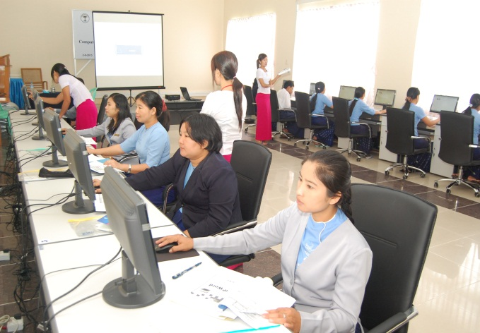
The Union Civil Service Board faces challenges to enhancing the transparency and openness of their work, and in facilitating efficient and effective day to day management of civil service affairs. A key bottleneck, identified by the government of Myanmar, to address these challenges includes weak ICT infrastructure and capacity, and the absence of strategies to promote e-governance.
Figure 2 Students of Computer Training, CSIC, November 2013
UNDP assessed the UCSB’s current ICT infrastructure, including currently available software and business processes, and produced a draft strategy document for the UCSB to improve policies, processes and procedures that are based on the optimal use of ICT technologies- an ‘e-governance’ strategy. This strategy has not yet been adopted. However, as an entry point, UNDP implemented a basic training programme on the use of computers and the principles of e-governance, targeting key stakeholders in e-governance reform, and staff in the UCSB, and provided computers and accessories for computer learning center in UCSB. These trainings improved trainees’ computer skills as a part of the compulsory training curriculum for civil servants, and raised awareness of the use of ICT to enhance effective government.
At a higher level, UNDP has been collaborating with the Ministry of Communication, Information and Technology to review national legal frame works and to identify priorities for e-government implementation, reviewing the 2005 ICT master plan and formulating a strategy for broader e-governance reform in the public sector. This work on the national level will be phased out in 2014.

2.3 Improvements in the production of training content; (b) training curriculums and (c) quality of delivery of training and (d) training environments.
UNDP worked closely with the Union Civil Service Board (UCSB) to identify key areas for improvement in civil servant training, to establish a way forward to enhance quality of training in the long term, and to support incremental improvements to the delivery of existing trainings. UNDP also supported the UCSB in their engagement with ASEAN, and to take up leadership of issues regarding civil service training within the region.
Figure 5 Preliminary Meeting of the ACCSM in Bagan, February 2013
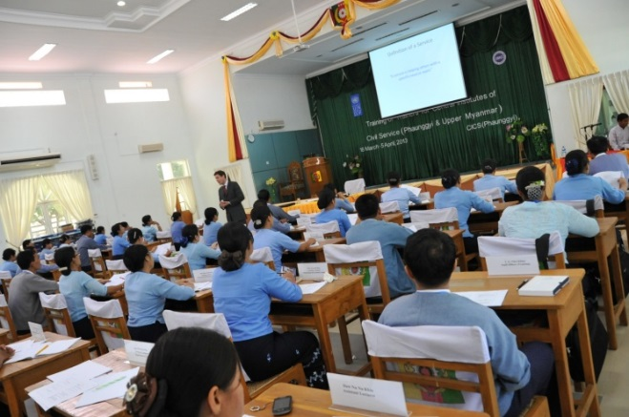
In 2013, UNDP conducted a capacity assessment of Union Civil Service Board (UCSB) and two central training institutes- analysing the training policy and practices of the central institutes of the UCSB and other training institutions, including training environment, style, and delivery- and defined a strategy for UNDP support to the training that links with a longer – term sustainable approach to capacity development for public sector performance. Key recommendations emerging from the capacity assessment included a training needs assessment for whole civil service, reducing classroom size to create a different learning environment, varying the length of training courses, making strategic changes to the focus and style of trainings (including a move away from ‘pure science’, and the improvement of library facilities and other resources.
Figure 3 International Management Group TOT
UNDP made some headway into improving the quality and conduct of training for civil servants, by providing several workshop-based trainings which targeted trainers in both the CICS centres, and in line ministry training departments. UNDP advised government trainers on how to design, implement, and evaluate training. UNDP collaborated with the International Management Group (IMG) to provide a Training-of-Trainers (ToT) Course for CICS teaching staff stationed at CICS Phaunggyi and CICS Pyin Oo Lwin, and in November 2013, UCSB held a further training targeting 30 participants from line ministry training centers.
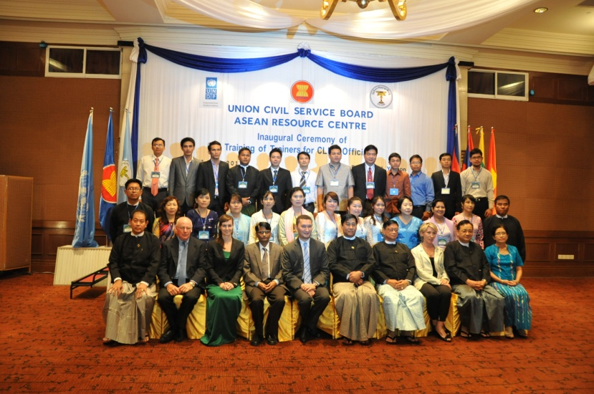
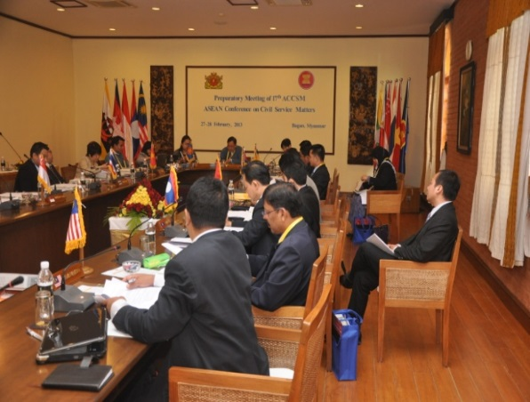
As Myanmar has taken on responsibility within ASEAN for promoting improved training quality, UNDP’s work to enhance training quality has raised the profile of the Myanmar UCSB within the region. Through the newly established ASEAN Resource Centre (ARC) in the UCSB, ASEAN member countries UNDP scaled up our Training of Trainers workshop approach for the countries of Cambodia, Lao PDR, Myanmar & Vietnam (CLMV). In addition, UNDP supported ARC of UCSB’s capacity to hold preliminary meeting and Senior Managers Meeting for the ASEAN Cooperation on Civil Service Matters (ACCSM).
Figure 4 TOT workshop for CLMV countries, June 2013

2.4 Establish programmes for leadership development for public sector managers and leaders and young leaders training and mentoring initiatives.
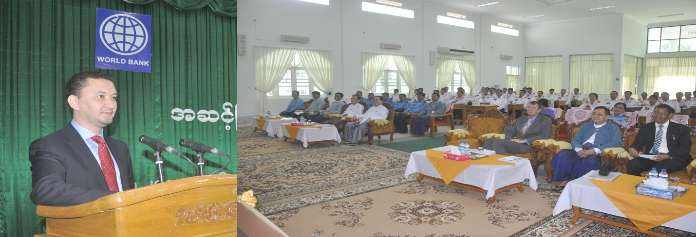
The Government of Myanmar recognizes that leadership will be critical to drive meaningful change in public administration. Although UNDP’s work in this area was small scale in 2013, supporting the development and completion of a training course targeting civil service senior management, this has helped form relationships allowing the programme to take a more comprehensive approach in 2014. At the request of the Chairman of the Union Civil Service Board (UCSB), UNDP held the first senior management module in June 2013 which aimed to improve the management and administrative skills of senior civil service personnel in Myanmar. The course included participation and facilitation by a wide-range of experts from inside and outside government, with respective line ministries, institutions, academia, and UN agencies in attendance. Deputy Director General and Director level government officials who are carrying out the advance management duties at the respective ministries in national level, sub national level, and local governments attended.
We got so many knowledge’s which are related to the leadership and management. Because of attending this course, we are sharing the knowledge and information, benefit to get team spirit and unity. At the present situation in my country, this course is supporting to change our mind-set in work environment. This course is encouraged to enthusiast and develops for our job.
U Htay Win
Deputy Director General
Ministry of Hotels and Tourism

Figure 6 Mr. Toily Kurbanov, UNDP Country Director, and Participatns at Senior Management Training

FREQUENTLY ASKED QUESTIONS

Q. What is CPAP?
A. Country Programme Action Plan is the agreement signed between UNDP and Government of Myanmar regarding the programmes/ activities to be implemented by UNDP between 2013-2015.

Q. What are the main UNDP programmes under the CPAP 2013-2015?
A. There are three main UNDP programmes under the CPAP (also referred to as “Pillars”): 1. Local Governance; 2. Environment, Climate Change, Energy and Disaster Risk Reduction (DRR); & 3. Support to Democratic Governance in Myanmar.

Q. Under which Pillar does the Programme on Rule of Law and Access to Justice (RoL/A2J) fall?
A. The RoL/A2J Programme (also referred to as an “output”) falls under Pillar 3 i.e. Support to Democratic Governance.

Q. What is a Programme Document (Prodoc)?
A. Each of the 3 programmes/pillars has a Programme Document (prodoc) that describes the programmes/outputs, which will be implemented under each Pillar for the period 2013-2015. The prodocs are a part of the signed CPAP (as annexes).

Q. What is an RRF?
A. The Results and Resources Framework is part of the prodoc and describes the broad results sought to be achieved, the indicative activities which may be implemented to achieve those results and the financial resources available/needed to implement the activities.

Q. What is an AWP?
A. Each Output has an Annual Work Plan (AWP), which describes in detail the activities for a particular year within the CPAP cycle (2013-2015)

Q. Is the AWP also signed (every year)?
A. The AWP is not signed but draws its guidance from the CPAP, the prodocs (including the RRF) and the national priorities.

Q. Can the RRF & /or the AWP be changed?
A. The RRF & AWP can be changed, if the circumstances require this. While mid-course corrections for AWPs are quite common, RRF is changed in exceptional cases.

Q. Who approves the changes to the RRF or the AWP?
A. Output Boards created under each “Output” of each “Pillar” are the governance structures that approve these changes.

UNDP GOVERNANCE STRUCTURES
Tier 1 - Output Boards
Core task: results management.
Decision prerogatives: approve Output Annual Work Plans; endorse Output Annual Progress Reports; review Output Results and Resources Frameworks (RRFs) and, if necessary, recommend changes to Pillar Boards; other decisions as delegated by Pillar Boards and as per UNDP rules and regulations.
Membership: 1-2 main government counterparts per output; 1 donor per output; UNDP; other partners as agreed upon between UNDP, government and donors; all participants at technical level (e.g. Output lead for UNDP; Director-level for government).
Frequency of meetings: twice a year.

Tier 2 - Pillar Boards
Core task: quality assurance of results; programme coherence and strategic focus.
Decision prerogatives: approve Output RRFs and, on this basis, Pillar RRF; consider recommendations and approve changes to RRFs (except substantial changes to be reviewed by the Steering Committee, ref below); provides overall guidance to Output Boards on Annual Work Plans; where appropriate, recommend alignment with Sector Working Groups; endorse Annual Pillar Progress Reports; other decisions as delegated by the Steering Committee and as per UNDP rules and regulations.
Membership: 1-2 main government counterparts per each output; 1-2 donor per pillar; UNDP; other partners as agreed upon between UNDP, government and donors; all participants at management level (e.g. Pillar team leader for UNDP; Director-General-level for government).
Frequency of meetings: twice a year.

Tier 3 – Steering Committee
Core task: strategic direction and overall alignment with national priorities.
Decision prerogatives: conducts annual country programme review; provides overall guidance to Pillar Boards on their respective RRFs; approves substantial changes in the RRF, such as concerning deletion, addition or amalgamation of entire outputs; commissions independent evaluations and approves UNDP management responses; considers overall duration of the programme cycle in line with evolving national priorities and timelines and makes appropriate recommendations to Government and UNDP.
Membership: all government counterparts and all donors; UNDP; UN agencies; other partners as agreed upon between UNDP, government and donors; all participants at executive level (e.g. Country Director for UNDP; Deputy Minister for government).
Frequency of meetings: once every year.

